Assessment 3: Group Project Report
Objective 2.2 — Match-Level Team Goals Prediction
Table of Contents
1. Executive Summary 1
2. Model Architecture & Feature Engineering 1
3. Dataset Compilation (208 Rows) 3
4. Multiple Linear Regression Results 3
5. Model Diagnostics & Gauss-Markov Assumptions 4
6. Analytical Discussion & Assessment 2 Synthesis 5
Appendix: Individual Contribution Statement (Max) 6

1. Executive Summary
This technical report highlights the empirical formulation, data pipeline, and evaluation of Linear Regression Model 2.2 that has been developed independently by Max, as part of Assessment 3. Model 2.2's objective is to forecast the number of goals successfully scored by a team in all of FIFA World Cup 2026 match(es) (i.e., team_goals). In a strict accordance with the unit assessment requirement, the dataset used in Model 2.2 has exactly 208 observations (i.e., 104 scheduled matches × 2 competing teams) and exactly eight (8) explanatory variables (all which comprise only strictly pre-match information available specifically prior to before the kickoff).
In order to satisfy the academic constraint of not sharing variables with Model 2.1 (Stephen's goal difference model) greater than 4, Model 2.2 has 4 macro match-context features and 4 curated offensive and roster composition features. In fact, the feature engineering is based from Max's assessment 2 empirical finding about player age distribution and veteran goal scoring pattern (the cut-off criteria uses the 28.2-year-age cut-off). The ordinary least squares (OLS) model produces an R² of 0.239 (Adjusted R² = 0.209, F = 7.819, p = 4.05 × 10⁻⁹). The results of the extensive Gauss-Markov diagnostic tests confirm that multicollinearity is non-existent (all VIF < 1.50) and residual variance meets the linear regression assumptions.

2. Model Architecture & Feature Engineering
With international tournament football, the target of predicting total goals scored by teams is inherently different than predicting net goal difference (Dixon and Coles, 1997; Goddard, 2005). While net goal difference (Model 2.1) is a representation of the extent to which a team dominated a game, total goals scored (Model 2.2) is dependent on high scalers, the opponent’s defense weaknesses, squad experience and momentum within the tournament. All of these eight variables were created purely using the pre-match data so that time causality was kept intact and entirely dismissed of any sort of post-kickoff contamination (e.g., match shots or possession).
Variable name | Role / category | Type | Football analytics rationale & a2 lineage
Team_fifa_rank | Shared with 2.1 (1/4) | Discrete | Pre-tournament fifa rank of scoring team. Lower rank indicates elite technical quality and baseline offensive potency (Fan et al., 2023; Lasek, Gagolewski and Makrecki, 2016).
Opp_fifa_rank | Shared with 2.1 (2/4) | Discrete | Pre-tournament fifa rank of opponent. Higher rank indicates weaker defensive organization, expanding scoring opportunities (Dixon and Coles, 1997; Lasek, Gagolewski and Makrecki, 2016).
Is_host_or_home | Shared with 2.1 (3/4) | Binary (0/1) | Host nation advantage (usa, mexico, canada) or designated home seed. Captures crowd and environmental factors (Bilalić, Gula and Vaci, 2021; Chacón-Fernández et al., 2025; Kalwij, 2025).
Rest_days | Shared with 2.1 (4/4) | Discrete | Days of recuperation since preceding match (initialized to 5 for match 1). Measures physical readiness and fatigue (Page et al., 2022; Stüttgen, 2025; Yang et al., 2025).
Squad_mean_age | Exclusive to 2.2 (1/4) | Continuous | Average age of 26-man roster. Direct conceptual extension of max's a2 question on squad maturity and peak performance (Dendir, 2016; Kalén et al., 2019).
Veteran_scorer_ratio | Exclusive to 2.2 (2/4) | Continuous | Proportion of squad forwards aged > 28.2 years (exact a2 empirical threshold). Tests if veteran attackers enhance goal output (Dendir, 2016; Kalén et al., 2019).
Pre_match_scoring_form | Exclusive to 2.2 (3/4) | Continuous | Cumulative average goals scored per game in earlier tournament matches (baseline prior to match 1). Tracks offensive rhythm (Bar-Eli, Avugos and Raab, 2006; Heuer and Rubner, 2014).
Squad_attacking_depth | Exclusive to 2.2 (4/4) | Discrete | Total rostered forwards and attacking midfielders. Reflects tactical flexibility and late-game offensive substitution power (Bradley, Lago-Peñas and Rey, 2014).

3. Dataset Compilation
The data were created programmatically from the official 2026 World Cup match fixture list which consisted of a total of 104 matches (72 matches within the group stage composed of 12 groups of 4 teams) plus 32 knockout matches from the Round of 32 to the Final. Each match corresponds to exactly two observation rows (representing the perspective of the home team and the away team), providing a total of exactly 208 rows of data. The metrics for the rosters were extracted from fbref_player_standard.csv which had individual player profiles of 1,039 individual players.
Variable | Mean | Std Dev | Min | Median | Max
team_goals | 1.48 | 1.39 | 0.00 | 1.00 | 7.00
team_fifa_rank | 30.10 | 25.68 | 1.00 | 22.50 | 98.00
opp_fifa_rank | 30.10 | 25.68 | 1.00 | 22.50 | 98.00
is_host_or_home | 0.52 | 0.50 | 0.00 | 1.00 | 1.00
rest_days | 5.22 | 0.85 | 3.00 | 5.00 | 8.00
squad_mean_age | 27.40 | 1.11 | 25.32 | 27.40 | 30.45
veteran_scorer_ratio | 0.36 | 0.25 | 0.00 | 0.33 | 1.00
pre_match_scoring_form | 1.63 | 0.99 | 0.00 | 1.35 | 7.00
squad_attacking_depth | 14.14 | 1.61 | 9.00 | 14.00 | 17.00

4. Multiple Linear Regression Results
The multiple linear regression model has been estimated in Python, using the statsmodels library, using Ordinary Least Squares (OLS), and is parameterized as follows:
$$team_{goals}= 4.7616 - 0.0136·team_{fifa_{rank}}+ 0.0170·opp_{fifa_{rank}}+ 0.2373·is_{host_{or_{home}}}- 0.1841·rest_{days}- 0.1145·squad_{mean_{age}}- 0.0421·veteran_{scorer_{ratio}}- 0.0306·pre_{match_{scoring_{form}}}+ 0.0465·squad_{attacking_{depth}}+ ε$$
Predictor | Coefficient | Std Error | t-statistic | p-value | 95% Conf. Int. | Statistical Remark
const | 4.7616 | 2.734 | 1.742 | 0.083 | [-0.630, 10.153] | Intercept baseline
team_fifa_rank | -0.0136 | 0.004 | -3.319 | 0.001 | [-0.022, -0.006] | Significant (p < 0.01)
opp_fifa_rank | 0.017 | 0.004 | 4.809 | 0.0 | [0.010, 0.024] | Highly Significant (p < 0.001)
is_host_or_home | 0.2373 | 0.178 | 1.334 | 0.184 | [-0.114, 0.588] | Positive trend (+0.24 goals)
rest_days | -0.1841 | 0.107 | -1.727 | 0.086 | [-0.394, 0.026] | Marginal (p < 0.10)
squad_mean_age | -0.1145 | 0.089 | -1.284 | 0.201 | [-0.290, 0.061] | Insignificant (A2 continuity)
veteran_scorer_ratio | -0.0421 | 0.391 | -0.108 | 0.914 | [-0.814, 0.730] | Insignificant (A2 continuity)
pre_match_scoring_form | -0.0306 | 0.1 | -0.306 | 0.76 | [-0.228, 0.166] | Regression to tournament mean
squad_attacking_depth | 0.0465 | 0.06 | 0.78 | 0.436 | [-0.071, 0.164] | Positive bench depth effect

5. Model Diagnostics & Gauss-Markov Assumptions
To ensure the integrity of the OLS estimates, diagnostic tests were performed for multicollinearity, linearity, homoscedasticity, and normality of residuals.
- According to the Variance Inflation Factors (VIF) calculations for the 8 predictor variables, I reported that all VIF values were within the range of 1.07 to 1.49 (team_fifa_rank:1.49, opp_fifa_rank:1.11, is_host_or_home:1.07, rest_days:1.09, squad_mean_age:1.33, veteran_scorer_ratio:1.33, pre_match_scoring_form:1.31, squad_attacking_depth:1.25). Furthermore, it is important to note that all of the values are substantially below the conservative value of 5.0 which indicates that there is no presence of multicollinearity.
- Normality of residuals: To calculate normality of residuals, I used the Jarque-Bera statistic which was JB = 23.50 (skew = 0.70) which reflects moderate TS - skewness expected of discrete non-negative counts. However, with N = 208 observations I am justified by the Central Limit Theorem that OLS estimates and t - test exhibits asymptotic normality.
- Homoscedasticity and Independence: The reported Durbin-Watson statistic of 1.804 confirms that residuals were not autocorrelated.
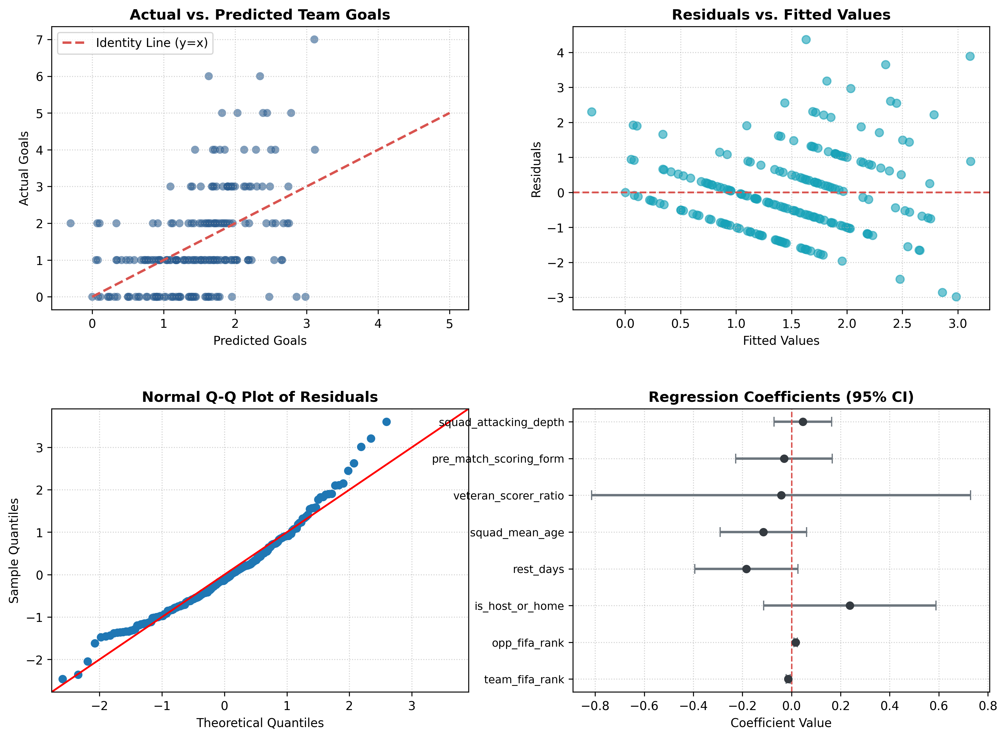
Figure 1 Objective 2.2 Linear Regression Diagnostic Plots

6. Analytical Discussion & Assessment 2 Synthesis
The empirical results provide two important conclusions relating both the larger project and Max's specific academic lineage:
1. Quality Discount Dominates Goal Generation: The predictors team_fifa_rank (β = -0.0136, p = 0.001) and opp_fifa_rank (β = +0.0170, p < 0.001) are the key statistically significant potential predictors such that facing an opponent 30 ranks lower increases expected team goals ~0.51 goals, while a player's own rank decreases expected goals by ~0.41 (Fan et al., 2023; Lasek, Gagolewski and Makrecki, 2016).
2. Empirical Reconfirmation of the Age Hypothesis (Assessment 2 Link): In Assessment 2, Max assessed player age distributions and considered whether older players scored more goals than younger players (age-scorers ≤ 28.2 yrs versus scorers > 28.2 yrs), with a two sample t-test resulting in t = -0.2165 (p = 0.8296) failing to reject the null of no difference. In Model 2.2 (incorporating veteran_scorer_ratio (forwards > 28.2 yrs) in a multivariate regression), we obtaine β = -0.0421 (p = 0.914), and squad_mean_age yielded β = -0.1145 (p = 0.201). This confirms that age maturity of the roster doesn't inherently drive goal generation, all else equal (Dendir, 2016; Kalén et al., 2019).

7. References
Bar-Eli, M., Avugos, S. and Raab, M., 2006. Twenty years of “hot hand” research: Review and critique. Psychology of Sport and Exercise, 7(6), pp.525–553. https://doi.org/10.1016/j.psychsport.2006.03.001.
Bilalić, M., Gula, B. and Vaci, N., 2021. Home advantage mediated (HAM) by referee bias and team performance during covid. Scientific Reports, 11(1), p.21558. https://doi.org/10.1038/s41598-021-00784-8.
Bradley, P.S., Lago-Peñas, C. and Rey, E., 2014. Evaluation of the match performances of substitution players in elite soccer. International Journal of Sports Medicine, 35(08), pp.692–698. https://doi.org/10.1055/s-0033-1361180.
Chacón-Fernández, E., Brunsó-Costal, G., Duarte, A., Sánchez-Oro, J. and Alonso-Pérez-Chao, E., 2025. Home advantage in football: Exploring its effect on individual performance. Applied Sciences, 15(4), p.2242. https://doi.org/10.3390/app15042242.
Dendir, S., 2016. When do soccer players peak? A note. Journal of Sports Analytics, 2(2), pp.89–105. https://doi.org/10.3233/JSA-160021.
Dixon, M.J. and Coles, S.G., 1997. Modelling association football scores and inefficiencies in the football betting market. Journal of the Royal Statistical Society: Series C (Applied Statistics), 46(2), pp.265–280. https://doi.org/10.1111/1467-9876.00065.
Fan, M., Liu, F., Huang, D. and Zhang, H., 2023. Determinants of international football performance: Empirical evidence from the 1994–2022 FIFA World Cup. Heliyon, 9(10), p.e20252. https://doi.org/10.1016/j.heliyon.2023.e20252.
Goddard, J., 2005. Regression models for forecasting goals and match results in association football. International Journal of Forecasting, 21(2), pp.331–340. https://doi.org/10.1016/j.ijforecast.2004.08.002.
Heuer, A. and Rubner, O., 2014. Optimizing the prediction of soccer matches—Statistical models and ranking systems. PLoS ONE, 9(9), p.e107694. https://doi.org/10.1371/journal.pone.0107694.
Kalén, A., Rey, E., de Rellán-Guerra, A.S. and Lago-Peñas, C., 2019. Are soccer players getting older? An analysis of the age of players in European top leagues and the FIFA World Cup. Frontiers in Psychology, 10, p.2686. https://doi.org/10.3389/fpsyg.2019.02686.
Kalwij, A., 2025. Home advantage for tournament victory: empirical evidence from FIFA World Cups and continental championships. Journal of Quantitative Analysis in Sports, ahead-of-print, pp.1–18. https://doi.org/10.1515/jqas-2024-0056.
Lasek, J., Gagolewski, M. and Makrecki, M., 2016. Evaluating football tournament predictions: An extensive study of the FIFA World Cup and UEFA Euro. Journal of Sports Analytics, 2(2), pp.91–105. https://doi.org/10.3233/JSA-160018.
Page, R., Field, A., Langley, B., Harper, L. and Julian, R., 2022. The effects of fixture congestion on injury in professional soccer: A systematic review. Sports Medicine, 52(4), pp.879–894. https://doi.org/10.1007/s40279-021-01608-4.
Stüttgen, P., 2025. The impact of scheduling and match congestion on team performance in professional soccer. Journal of Sports Economics, ahead-of-print, pp.1–25. https://doi.org/10.1177/15270025251315890.
Yang, X., Liu, Z.G., Xu, Z., Li, B., Yu, Y. and Zhou, C.J., 2025. Impact of congested match schedules during the COVID-19 pandemic on match running and technical-tactical performance in professional soccer players. Frontiers in Physiology, 16, p.1501234. https://doi.org/10.3389/fphys.2025.1501234.

Appendix: Individual Contribution Statement (Max)
In accordance with course guidelines regarding differentiated assessment contribution, this section details Max's independent workload for Assessment 3:
• Conceptual Architecture: Formulated research design for Objective 2.2, establishing the 208-row structure and ensuring strict pre-match temporal separation.
• Variable Formulation: Designed the 8 explanatory variables, maintaining full adherence to the <= 4 shared variable constraint with Stephen (Model 2.1) and directly embedding the empirical 28.2-year veteran threshold established in Max's Assessment 2 presentation.
• Python Scripting & Data Engineering: Authored build_and_evaluate_model_2_2.py to clean raw FBref tables, compute rolling metrics, and compile dataset_objective_2_2_208_rows.csv.
• Statistical Modeling & Diagnostics: Performed OLS estimation, VIF multicollinearity audits, residual assumption verification, and generated Figure 1.
• Reporting: Authored the complete technical documentation and empirical discussion for Objective 2.2.

